FSM Based PUF Model Results

We are using the PUF to authenticate the division process to proceed if it doesn’t match then we don’t get the expected results.

Fig 1: invalid output when the PUF challenge doesn’t match

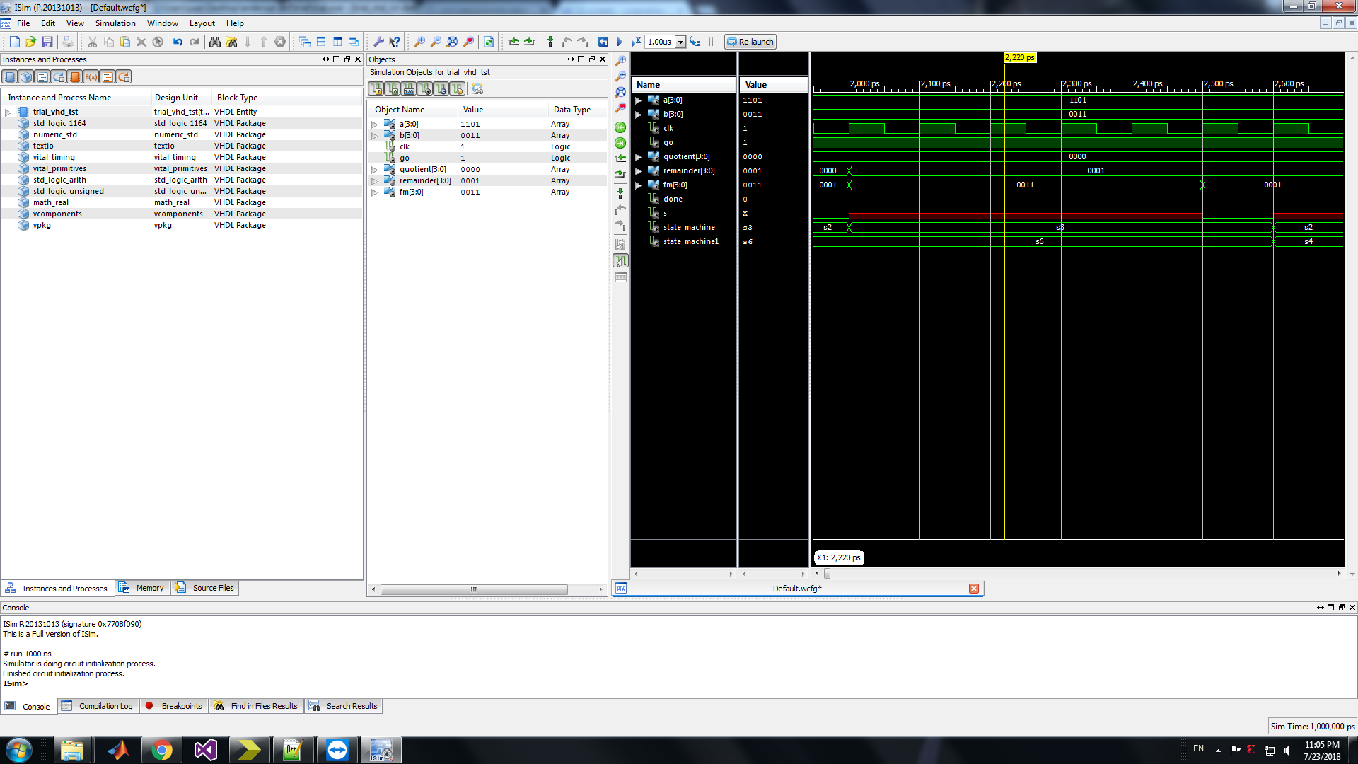

Fig 2: valid output when the PUF challenge matches

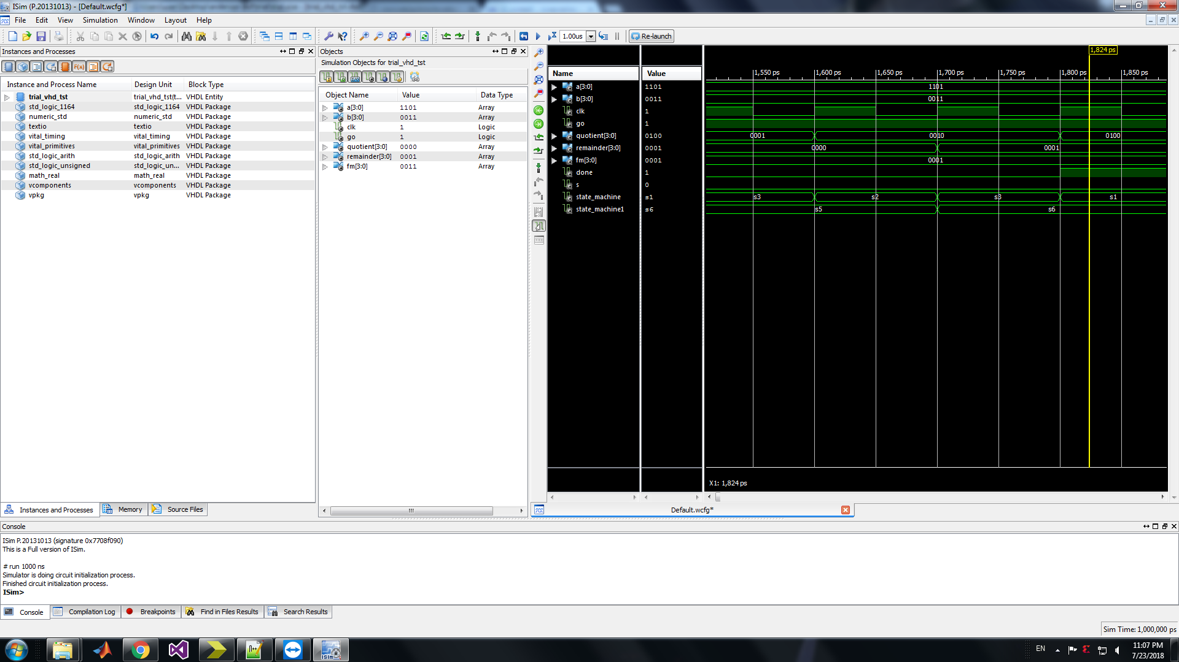

Here we have evaluated the PUF for a 4 bit challenge and we can see that in the figure that only when the challenge is “0001” we can generate the results. Otherwise, we won’t be able to get generate the output.